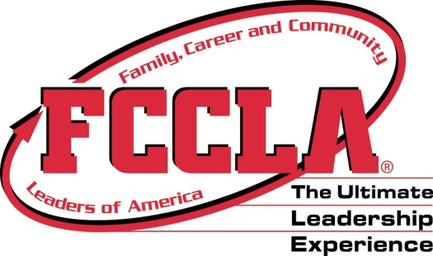

ARKANSAS FCCLA
OFFICER APPLICATION FORM

School District
Chapter l
District (Check all offices willing to serve:) District President District Division Office
State State
National National

CANDIDATE INFORMATION

Name
Age
Grade this year
Home Address
Home Phone
Cell Phone
E-mail Address
Parent/Guardian

ADVISER INFORMATION

Name
E-mail address
School
School Address
School phone
Cell Phone

Candidate (Candidate’s Adviser): This form (Application Form) shall be submitted to the District President’s Adviser at least two weeks prior to the Planning/Election Meeting.

District President’s Adviser: Give this form and the Qualification/Assurance form to the State Office representative at the conclusion of the Planning/Election Meeting.

Page 1
Arkansas Association of Family, Career and Community Leaders of America, August 2017

